EXPERIMENT 4  
\* shell cript that determines the period for which a specified user is working on the system.

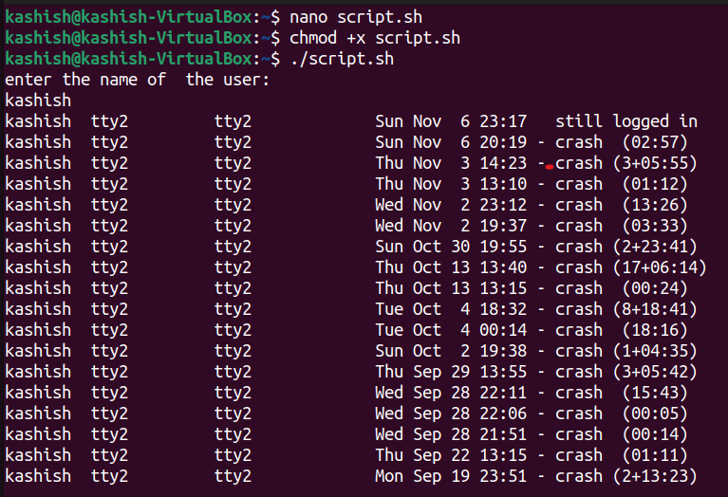

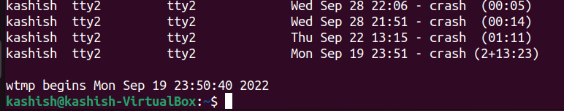

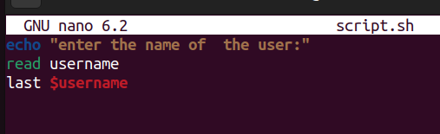

\*shell script that displays all the lines between start and wnd line numbers passed as argument .

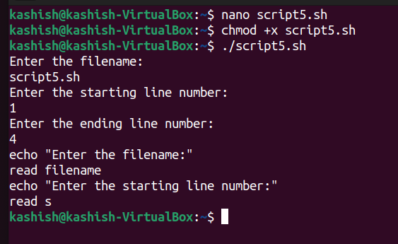

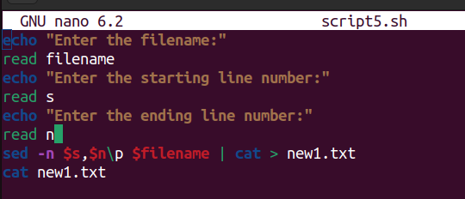

\*shell script that deletes all lines containing a specified word in one or more files supplied as agruments to it.

